**PRE SYNOPSIS**

**TOPIC - FARMING ASSISTANT WEB SERVICE**

**Area** – Python, My SQL, GUI, Javascript, HTML and Computer Vision .

**Type of Approach** – Software Based

* Bargaining feature for price negotiation
* Crop listings with quantity, quality, and price details
* Messaging system for direct communication
* Payment gateway integration for secure transactions

Top of Form

**Objective** –

1.To make the user friendly software application for farmers that can be accessed by anyone , that solves farmers compliances , brings transparency, boosts business communication for their use and benefits.

2.To Develop a model where the farmers can store , sell , buy inputs and other agriculture related equipments from an open market and ensure greater profitability.

3.Regularly solicit feedback from users to identify areas for improvement and new feature requests.

**Working Model –** Iterative Waterfall Model

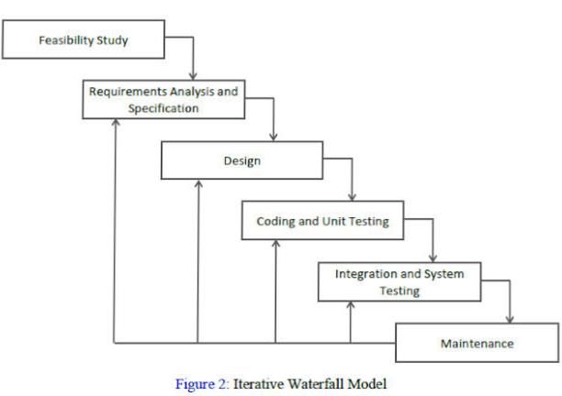The iterative waterfall model applied to the farming assistant web service involves a sequential process with feedback loops for continuous improvement. It begins with requirements gathering, followed by design, implementation, testing, deployment, and feedback collection. Based on feedback and analysis, updates and new features are iteratively developed, tested, and deployed.

Top of Form

**Name of Team Members** – Aviral Jaiswal(2101220100035), Himanshu Singh Chauhan (2101220100054)

**References -** 1.GeeksforGeeks:

<https://www.geeksforgeeks.org/software-engineering>

2.ChatGPT by OpenAI: https://chat.openai.com/